Ideation Phase
Brainstorm & Idea Prioritization Template

Date | 31 January 2026
Team ID | LTVIP2026TMIDS62122
Project Name | Startup Success Prediction System Using Machine Learning
Maximum Marks | 4 Marks

Brainstorm & Idea Prioritization Template:
Step-1: Team Gathering, Collaboration and Select the Problem Statement
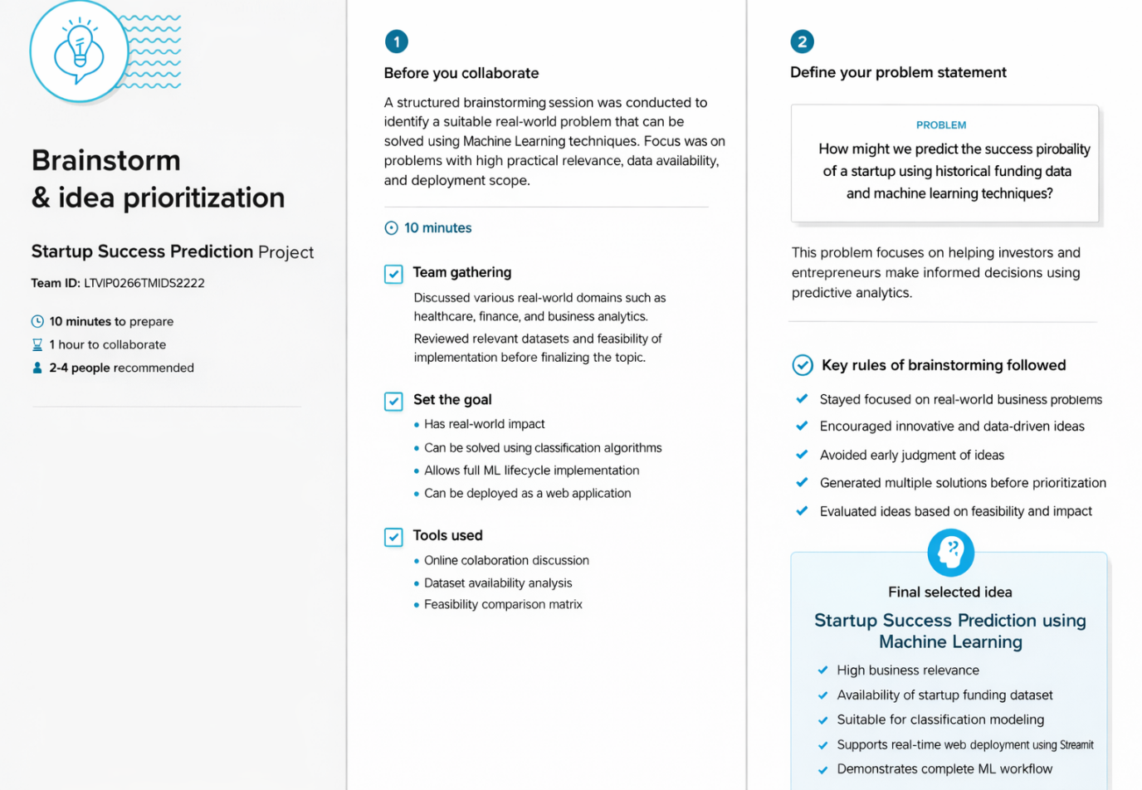

Step-2: Brainstorm, Idea Listing and Grouping
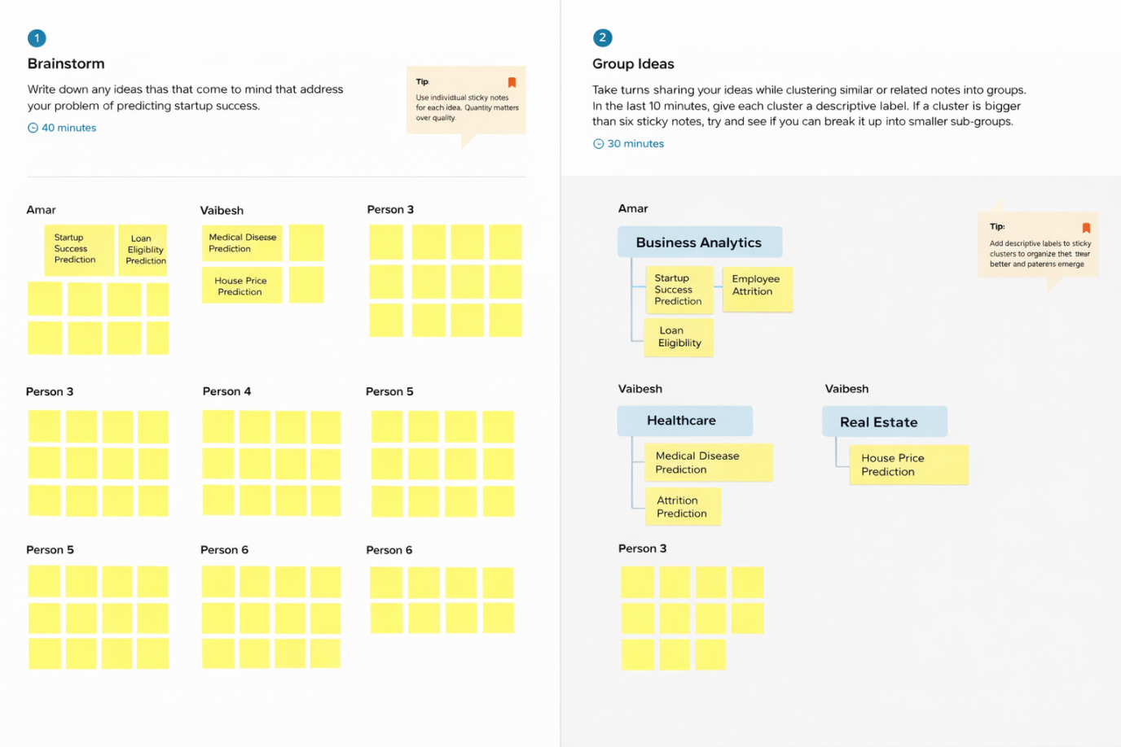
Step-3: Idea Prioritization
